JDBC

Questions
- What does the JDBC database URL specify?
-With JDBC, a database is represented by a URL (Uniform Resource Locator).
Connection conn = DriverManager.getConnection(url, username, password);

- Please describe the necessary steps to be done in order to execute and process a SQL query in java.
- get connection
- create statement
- execute
- handle exception
- process results
- Enumerate some advantages of the JDBC technology?
1) As JDBC uses Java, your application becomes platform
independent.
2) JDBC is used as front end. So, even if Back end changes,
it requires very less changes.
3) Java is distributed. Hence your JDBC i.e. database
application can also become distributed & take advantage
of robust API that Java provides.
- Which are the differences between JDBC-ODBC and JDBC driver?
1.ODBC is for Microsoft and JDBC is for java applications.
2.ODBC can't be directly used with Java because it uses a C interface.
3.ODBC makes use of pointers which have been removed totally from java.
4.ODBC mixes simple and advanced features together and has complex options for
simple queries, But JDBC is designed to keep things simple while allowing
advanced capabilities when required.
5.ODBC requires manual installation of the ODBC driver manager and driver on all
client machines. JDBC drivers are written in java and JDBC code is automatically
installable, secure, and portable on all platforms.
6. JDBC API is a natural Java Interface and is built on ODBC. JDBC retains some
of the basic feature of ODBC
- Please describe the role of connection-pooling.
It's a technique to allow multiple clinets to make use of a cached set of shared and reusable connection objects providing access to a database.
Opening/Closing database connections is an expensive process and hence connection pools improve the performance of execution of commands on a database for which we maintain connection objects in the pool. It facilitates reuse of the same connection object to serve a number of client requests. Every time a client request is received, the pool is searched for an available connection object and it's highly likely that it gets a free connection object. Otherwise, either the incoming requests are queued or a new connection object is created and added to the pool (depending upon how many connections are already there in the pool and how many the particular implementation and configuration can support). As soon as a request finishes using a connection object, the object is given back to the pool from where it's assigned to one of the queued requests (based on what scheduling algorithm the particular connection pool implementation follows for serving queued requests). Since most of the requests are served using existing connection objects only so the connection pooling approach brings down the average time required for the users to wait for establishing the connection to the database.
- Please enumerate some advantages and disadvantages of the PrepareStatement.
Advantages:
1)PreparedStatement helps us in preventing SQL injection attacks because it automatically escapes the special characters.
2)PreparedStatement allows us to execute dynamic queries with parameter inputs. 3)PreparedStatement provides different types of setter methods to set the input parameters for the query.
4)PreparedStatement is faster than Statement.
5)PreparedStatement helps us in writing object Oriented code with setter methods 6)PreparedStatement returns FORWARD_ONLY ResultSet

Disadvantages:
Using a PreparedStatement using two replacement parameters:
String sql = "SELECT COL1 FROM MYTABLE WHERE COL1 = ? AND COL2 = ?";
ps.setSetring("WORK");
ps.setString("FORFOOD");
Contrasted against a Statement using literals:
"SELECT COL1 FROM MYTABLE WHERE COL1 = 'WORK' AND COL2 = 'FORFOOD'";
When you execute these two queries, they can generate different explain plans, for example the Statement may use an index while the PreparedStatement may attempt a full table scan. The optimizer is choosing a more efficient explain plan for the Statement because it has more information on which to make a decision (the literal values). A full table scan will be significantly slower then using an index to return the same results. In some databases, you can provide hints, but in some cases, the only way to get this query to use an index is to provide the actual values WORK and FORFOOD in the query itself. When using literals rather then replacement parameters it should be more efficient to use Statement then PreparedStatement. So, in these cases, you should use a Statement rather then a PreparedStatement to get best performance from your query. And again, this issue comes up very infrequently but can be quite debilitating to an applications performance when it does occur.

- What is the difference between Statement and CallableStatement
TheJDBCStatement,CallableStatement, and PreparedStatement interfaces define the methods and properties that enable you to send SQL or PL/SQL commands and receive data from your database.
They also define methods that help bridge data type differences between Java and SQL data types used in a database.

Interfaces | Recommended Use
Statement | Use the for general-purpose access to your database. Useful when you are using static SQL statements at runtime. The Statement interface cannot accept parameters.
PreparedStatement | Use the when you plan to use the SQL statements many times. The PreparedStatement interface accepts input parameters at runtime.
CallableStatement | Use the when you want to access the database stored procedures. The CallableStatement interface can also accept runtime input parameters.

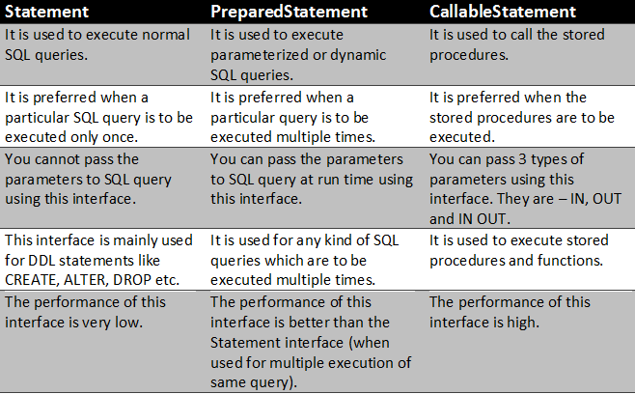

- Explain when should we use each of the following methods of Statement interface:
  - executeUpdate
  - executeQuery
  - executeBatch

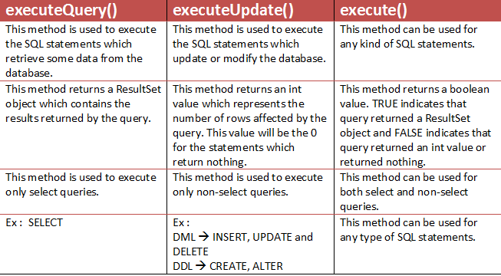

When you send several SQL statements to the database at once, you reduce the amount of communication overhead, thereby improving performance.
- JDBC drivers are not required to support this feature. You should use the DatabaseMetaData.supportsBatchUpdates() method to determine if the target database supports batch update processing. The method returns true if your JDBC driver supports this feature.
- The addBatch() method of Statement, PreparedStatement, andCallableStatement is used to add individual statements to the batch. The executeBatch() is used to start the execution of all the statements grouped together.
- The executeBatch() returns an array of integers, and each element of the array represents the update count for the respective update statement.
- Just as you can add statements to a batch for processing, you can remove them with the clearBatch() method. This method removes all the statements you added with the addBatch() method. However, you cannot selectively choose which statement to remove.

Problems
- Create a class which opens a connection to a database using JDBC_ODBC bridge.
- Write a java class that inserts into a database table (let say Users[FirstName,LastName,Email]) n records using PreparedStatement interface.
- For a database with the following structure, write a class that displays all students for a given department of a university.

Users
Id : int
Name: varchar
Email: varchar
Address: varchar
DepartmentId: int
Departments
Id: int
Name: varchar

- Write a class which opens a JDBC-ODBC connection to a given database, reads all records of a table (Persons[name, address, email, age]) and displays them ordered by name.
- Suppose that we have 2 tables with the same structure within a given database. Write a java class that allows you to copy all the data from one table to the other. Table should be given as execution arguments.
Table structure:
  - id: int
  - name: varchar
  - price: int

